**CHAROTAR UNIVERSITY OF SCIENCE & TECHNOLOGY**

**FACULTY OF TECHNOLOGY AND ENGINEERING**

DEPSTAR

CS442 - Data Science Analytics

Practical Exam

**18DCS007**

**AIM:**  
To develop a MapReduce application and implement a program that analyzes Earth Quake data.

**CODE:**

package hadoop;

import java.util.*;

import java.io.IOException;

import java.io.IOException;

import org.apache.hadoop.fs.Path;

import org.apache.hadoop.conf.*;

import org.apache.hadoop.io.*;

import org.apache.hadoop.mapred.*;

import org.apache.hadoop.util.*;

public class ProcessUnits {

//Mapper class

public static class E_EMapper extends MapReduceBase implements

Mapper<LongWritable ,/*Input key Type */

Text, /*Input value Type*/

Text, /*Output key Type*/

IntWritable> /*Output value Type*/

{

//Map function

public void map(LongWritable key, Text value,

OutputCollector<Text, IntWritable> output,

Reporter reporter) throws IOException {

String line = value.toString();

String lasttoken = null;

StringTokenizer s = new StringTokenizer(line,"\t");

String year = s.nextToken();

while(s.hasMoreTokens()) {

lasttoken = s.nextToken();

}

int avgprice = Integer.parseInt(lasttoken);

output.collect(new Text(year), new IntWritable(avgprice));

}

}

//Reducer class

public static class E_EReduce extends MapReduceBase implements Reducer< Text, IntWritable, Text, IntWritable > {

//Reduce function

public void reduce( Text key, Iterator <IntWritable> values,

OutputCollector<Text, IntWritable> output, Reporter reporter) throws IOException {

int maxavg = 30;

int val = Integer.MIN_VALUE;

while (values.hasNext()) {

if((val = values.next().get())>maxavg) {

output.collect(key, new IntWritable(val));

}

}

}

}

//Main function

public static void main(String args[])throws Exception {

JobConf conf = new JobConf(ProcessUnits.class);

conf.setJobName("max_earthquakeunits");

conf.setOutputKeyClass(Text.class);

conf.setOutputValueClass(IntWritable.class);

conf.setMapperClass(E_EMapper.class);

conf.setCombinerClass(E_EReduce.class);

conf.setReducerClass(E_EReduce.class);

conf.setInputFormat(TextInputFormat.class);

conf.setOutputFormat(TextOutputFormat.class);

FileInputFormat.setInputPaths(conf, new Path(args[0]));

FileOutputFormat.setOutputPath(conf, new Path(args[1]));

JobClient.runJob(conf);

}

}

**OUTPUT:**

DATASET

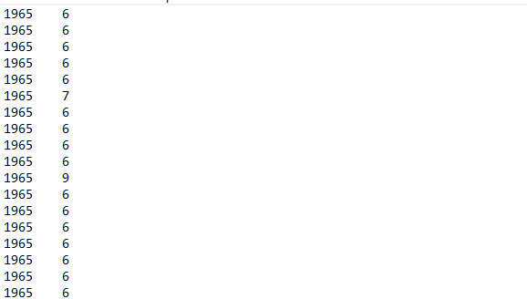

**HADOOP STEP IMAGES**





